## Hackathon - BIOMERO 101 - prep

How to set up a local BIOMERO instance on your **Windows** laptop (or **Windows** remote computer) ?

It consists basically of the following steps:

1. Prerequisite: Install Docker Desktop & Git
2. Prerequisite: Set up SSH
3. Set up (local) Slurm
4. Set up NL-BIOMERO

Note: We will explain setup with **Docker Desktop for Windows**, as it's the most user-friendly.   
But all these containers should also work under any Docker or Podman installation on any platform, or at least Windows and Linux.

Tip of the day: *You can get auto-complete in the terminal when typing folder of filenames by hitting tab a few times after typing a few letters. Very useful.*

### Prerequisite: Install Docker Desktop & Git

1. Install Docker Desktop: <https://docs.docker.com/desktop/>
   1. Windows: <https://docs.docker.com/desktop/setup/install/windows-install/>
      1. Use the Windows Subsystem for Linux **WSL** backend preferably (check <https://learn.microsoft.com/en-us/windows/wsl/install#install-wsl-command> to setup WSL, then make sure to enable this in Docker Desktop-Settings-General-’Use the WSL2 based engine’)
   2. Start Docker Desktop (you should have an App installed now)
2. Install Git (for Win): <https://gitforwindows.org/> (or <https://git-scm.com/downloads/win> )
3. Create a new folder to house your workspace (e.g. *D:/workspace*), for all the code etc.
4. Let’s get ready to download our required code and containers:
   1. Open a *PowerShell* terminal.
   2. I will provide commands below to copy and paste into the terminal in blue.
   3. To start, navigate to your workspace:   
      cd D:/workspace
   4. Clone the git repository for Slurm containers

git clone <https://github.com/TorecLuik/slurm-docker-cluster>

* 1. Clone the git repository for NL-BIOMERO containers

git clone https://github.com/Cellular-Imaging-Amsterdam-UMC/NL-BIOMERO.git

2. Prerequisite: Set up SSH

1. We have to set up SSH access between Slurm and BIOMERO, this will mimic the real thing. For that, you need a SSH key. Do we have it already?

ls ~/.ssh/

If this shows some files including id_rsa and id_rsa.pub, you can already have nice SSH keys. If it shows different encoding (not rsa), perhaps just create new rsa keys anyway.

1. If not, you need to generate some:

ssh-keygen -t rsa

Press enter a few times to accept the defaults.

ls ~/.ssh/

We should see id_rsa and the id_rsa.pub files now.

1. We also have to provide an alias inside our SSH config file, so BIOMERO can use it (for now the alias should be localslurm , to match the slurm-config.ini we will use).
   1. Do you have a config file yet?

ls ~/.ssh/config

That shows an error (don’t have it), or a file named config

* 1. If you don’t have a SSH config file yet, just copy our example file from NL-BIOMERO directory:

cp NL-BIOMERO/ssh.config.example ~/.ssh/config

* 1. If you already have a ssh config file (~/.ssh/config), you need to edit this file and add this new alias to it as shown below:

Host localslurm

HostName host.docker.internal

User slurm

Port 2222

IdentityFile ~/.ssh/id_rsa

StrictHostKeyChecking no

3. Set up (local) Slurm

1. We will install a Slurm setup onto our own computer:
   1. You should have a subdirectory called slurm-docker-cluster after cloning, let’s verify:

ls slurm-docker-cluster

This should show a list of files, including docker-compose.yml.

* 1. Now let’s set up, go into the folder:

cd slurm-docker-cluster

* 1. First, we’ll copy the public SSH key we created before to our current folder for the Slurm cluster access:

cp ~/.ssh/id_rsa.pub .

**Don’t miss the ‘.’ at the end, it is part of the command and means “this directory”** (which is still /slurm-docker-cluster since we didn’t cd anywhere else yet)

* 1. Now we build and run our Slurm containers using our favorite docker-compose

docker-compose up -d --build

*This tells Docker to build all containers that are part of this Slurm cluster, and then to up (turn on the containers) the cluster, in a detached -d style so that it doesn’t take over our terminal. You could also separate the commands into docker-compose build followed by a docker-compose up -d.*

* 1. After that is done (*building will take a while the first time*) you should see a lot of containers active after the up -d. E.g. check Docker Desktop:

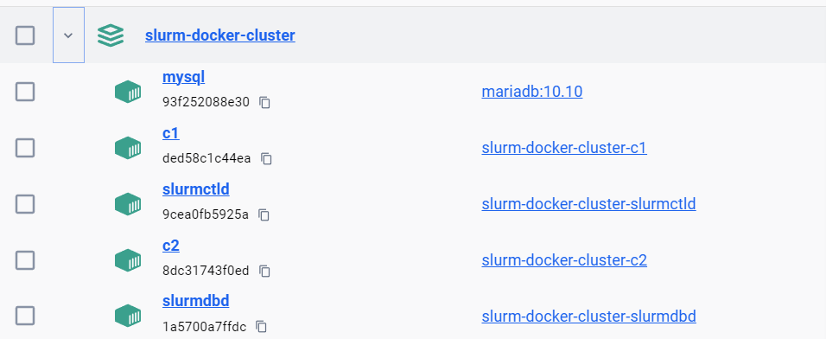

* 1. Finally, we want to test that we can access it with our SSH:

ssh -i ~/.ssh/id_rsa -p 2222 -o StrictHostKeyChecking=no slurm@localhost

This should open a terminal inside the slurmctld container showing [slurm@slurmctld data]$.   
*Great, SSH is working from your host computer, and you have a Slurm cluster!*

* 1. Now quit the SSH session again

exit

4. Set up NL-BIOMERO

1. Next, let’s setup OMERO w/ BIOMERO, ADI & CANVAS: the **NL-BIOMERO**
   1. First, go back to your workspace:

cd D:/workspace

* 1. You should have a subdirectory called NL-BIOMERO, after the clone, let’s verify:

ls NL-BIOMERO

This should show a list of files, including docker-compose-from-dockerhub.yml.

* 1. Get in there

cd NL-BIOMERO

* 1. Now let’s spin up NL-BIOMERO containers, but slightly different than before (*it will take a while again; this time it’s downloading from the internet*):

docker-compose -f .\docker-compose-from-dockerhub.yml up -d --build

* 1. You should see a lot of containers active after the up -d, e.g. in Docker Desktop:

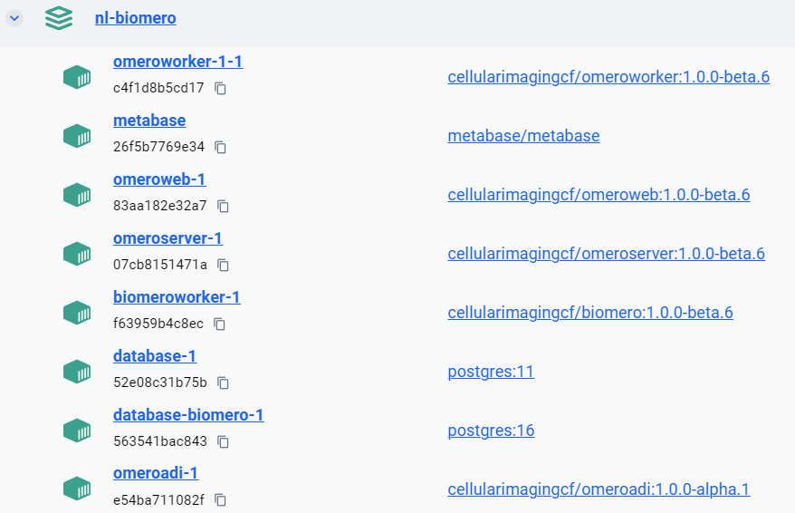

* 1. Now, you can access OMERO at localhost:4080 with user root pw omero  
     *Note that OMERO server takes a bit before accepting login requests from web (max 1 minute). Try again later.*

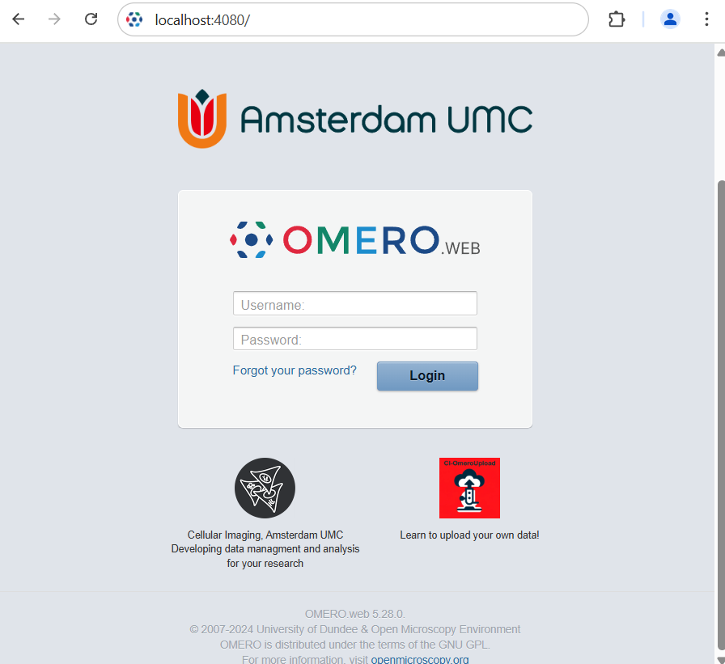

* 1. Create some new Projects, Datasets and Screens

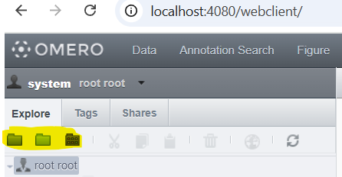

* 1. Then, you can now access the CANVAS plugin at the top:

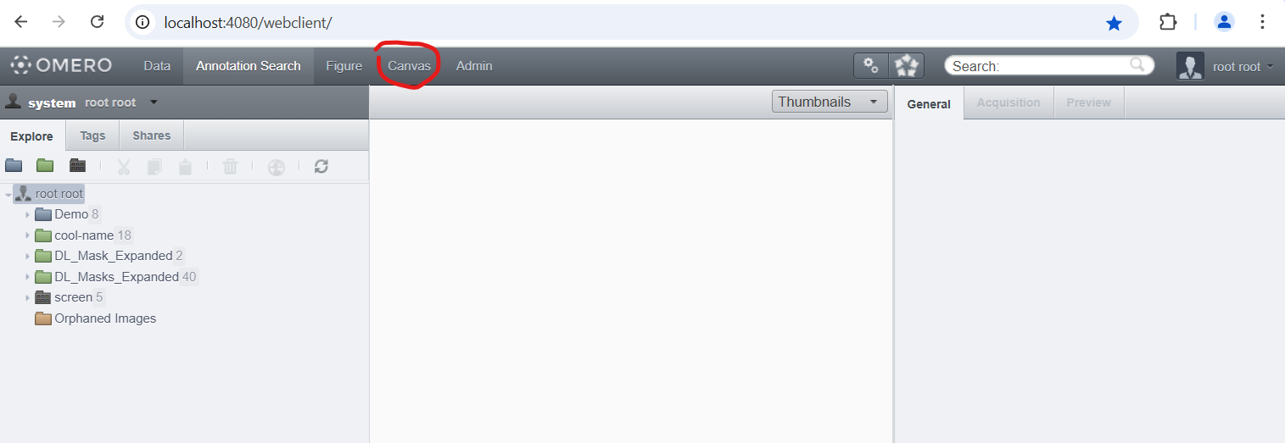

* 1. When you want to import your own files using ADI, place the files in (a subfolder of) the folder D:\Workspace\NL-BIOMERO\web\L-Drive
  2. Now use the CANVAS plugin in OMERO.web to initiate some imports with ADI

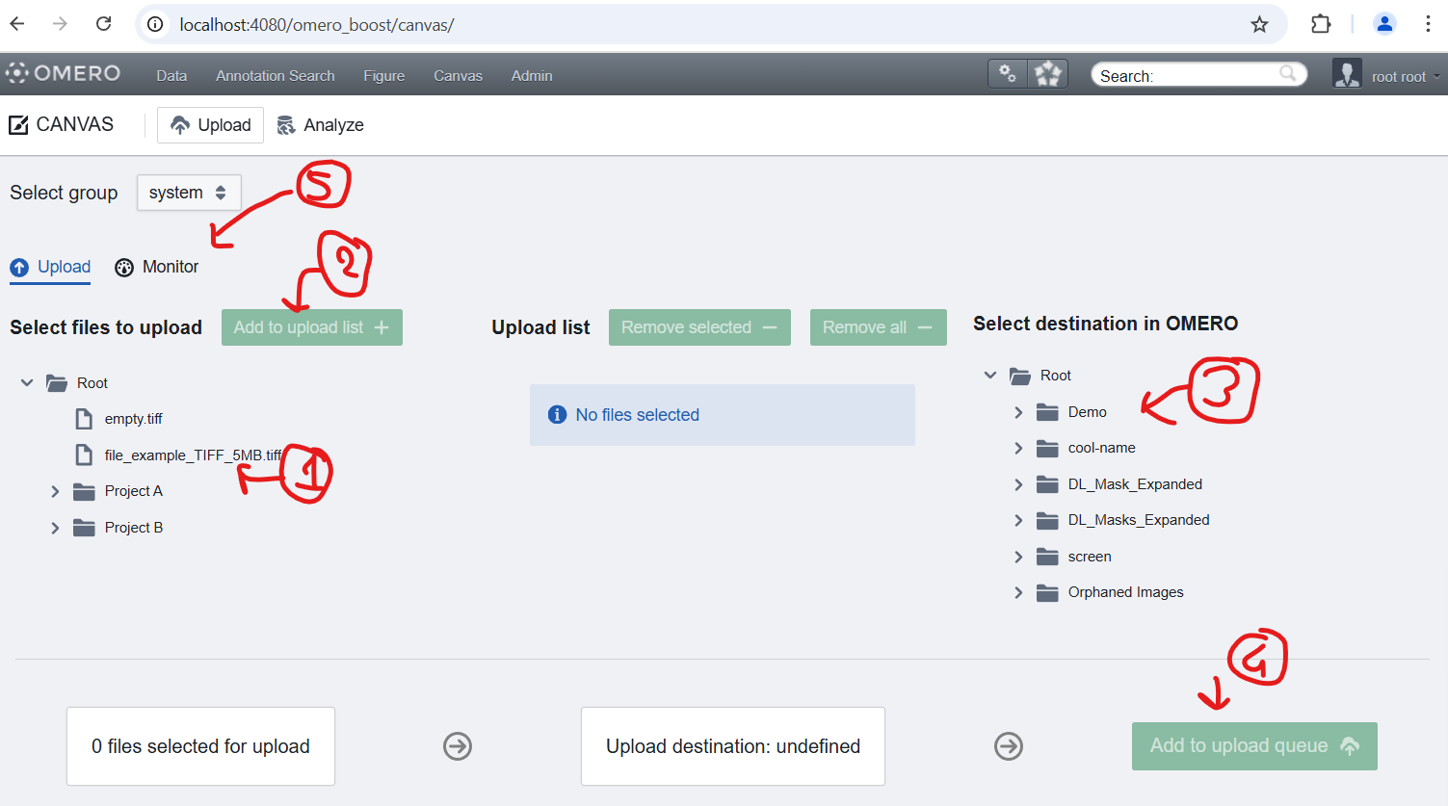

* 1. Next, we need to initialize BIOMERO once; Go to Analyze within CANVAS and then to the Admin tab

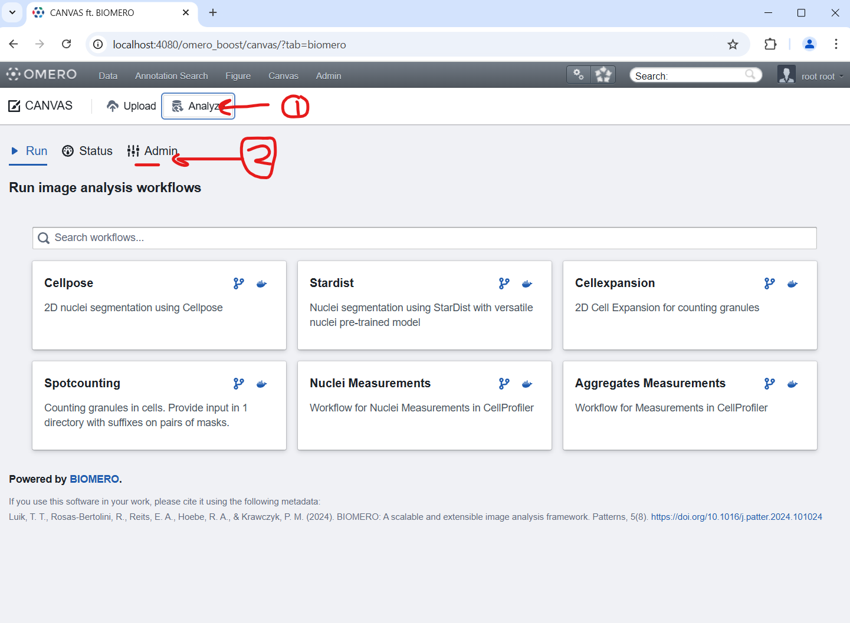

* 1. Here, we start the Slurm Init script to download all the workflow containers that we have configured to our Slurm cluster. Click Run script (also in the pop-up).

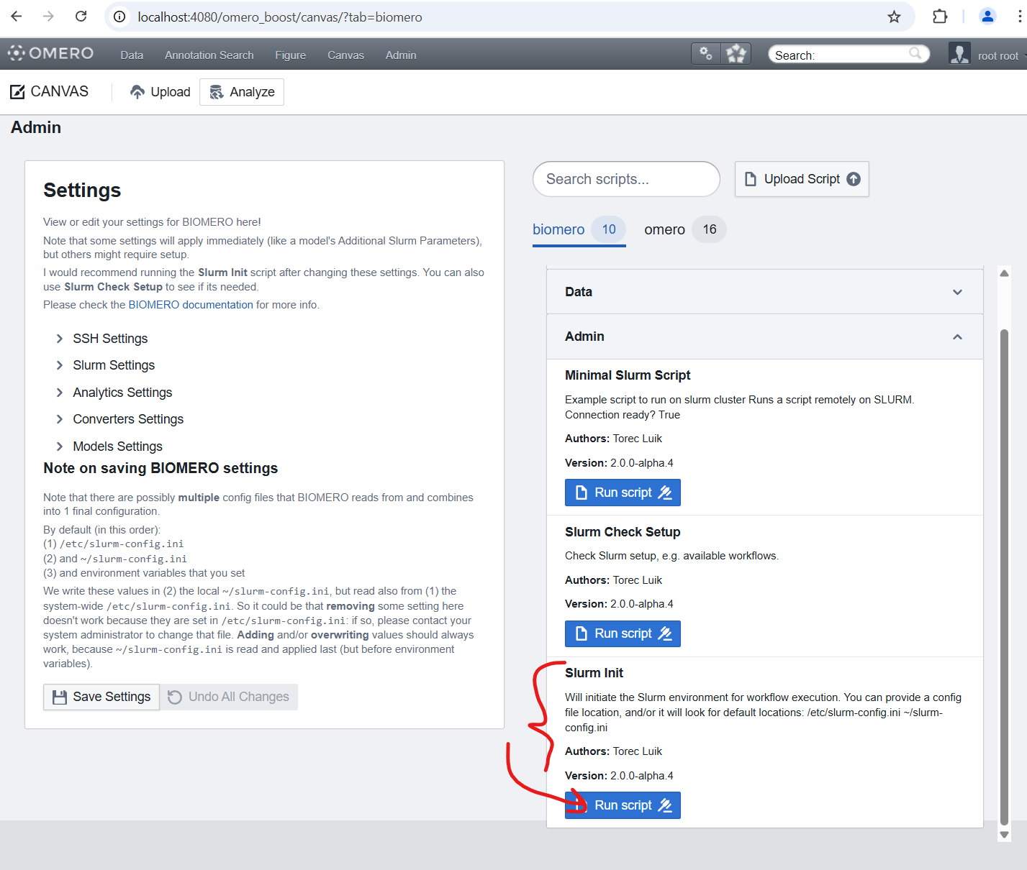

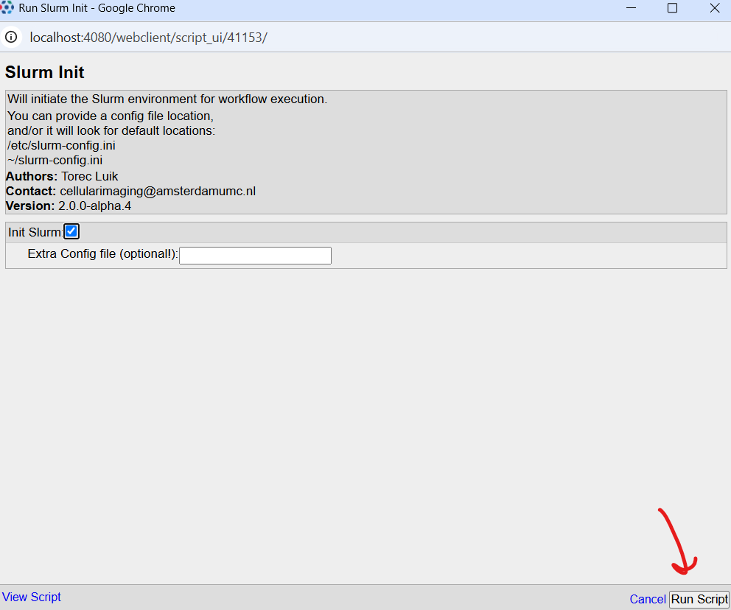

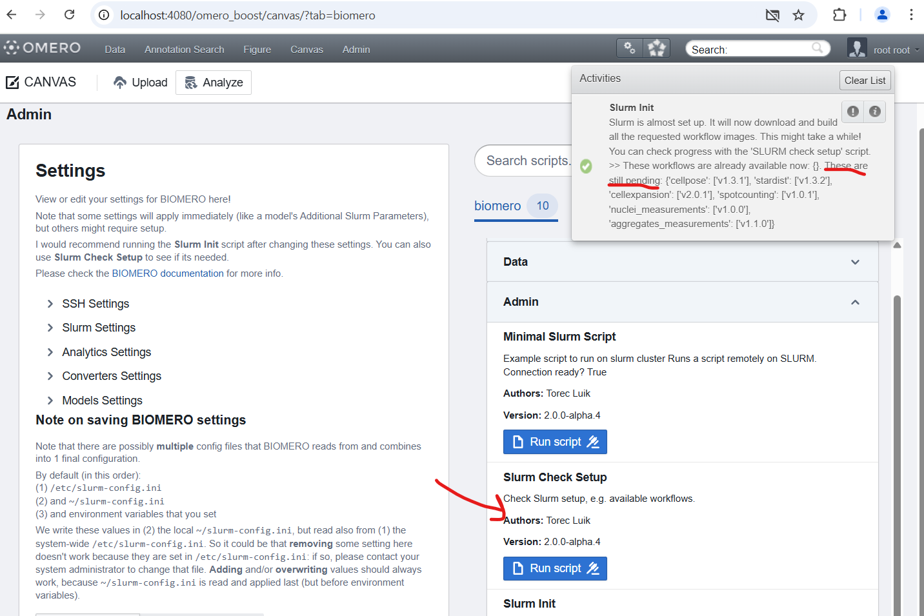

* 1. The script tells us that it is downloading the containers (These are still pending). This will take a while (> 10 minutes); you can check if there is any progress with the Slurm Check Setup script (look for Available Models instead of Pending Models).

Now you’ve got the whole NL-BIOMERO setup on your own computer!